**FUNDAZ ONLINE EVENT – ESCAPE CASTLE**

This document is to propose the idea for Fundaz online event

This game is about solving puzzles, riddles and codes to find the final answer. As the condition stands events cannot be conducted of offline so this event will continue the years to tradition of conducting exciting event with **Castel Escape.** A fun and interactive way of connection with people in times like this.

**Implementation:**

* Website will be created to use as medium to reach the audience
* Separate web pages will be created for each level, cut-scene, registration and final result
* A database for storing data of the participant and their score
* Images, content for stories, codes, riddles and other required content will be prepared

**Plot of the Game:**

Pedro De Santiago, a well-known magician but unsatisfied with the knowledge he has. So he decides to go in a quest of finding new magic. On his quest he stumbles upon a mysteries castle called castle of Akashic Records. Pedro Decides to explore the castle with a hope of finding mythical magic spells and objects. Fate had planned something else for him as he gets trapped in a spell and teleported in the prison at the top of the castle. Castle full of deadly traps and each floor has story of its own. Can he escape and continue his journey or die with an incomplete dream?

Help Pedro escape the castle in this mind blowing but tricky adventure. The secrets of the castle will reveal itself as you unfold the mystery of each floor. These secrets will lead you to the solution of final secret. Let’s see what fate awaits you on this journey!

**Gameplay:**

* The participant will be provided with an image, a short paragraph and a code or riddle based on science mathematics or aptitude.
* There will be cut scenes in between the levels to connect the stories of each floor and give a hint for next level.
* The participant is expected to keep a track on the answer as it will be using them to solve the last level.
* A time limit of 30 minutes will be provided to complete the game.
* The player will be allowed to refer internet for solving the riddles.

**Example:**

**I am formal military lieutenant, lt. Enigma Codeman; the guardian soul of 10th floor.**

**Be an opportunist! You have answer my puzzle to escape this floor. Be an opportunist!**

**Use all the resource you have at disposal.**

**For this puzzle you need to find the name of the place, the official name. READ CLOSELY, I need an official name of the place. No compromise with that!!**

**\*\*You can use web search to reach the answer\*\***

**Clue (which will be given in the cut scene before the level starts):Samuel F Breese’s invention**

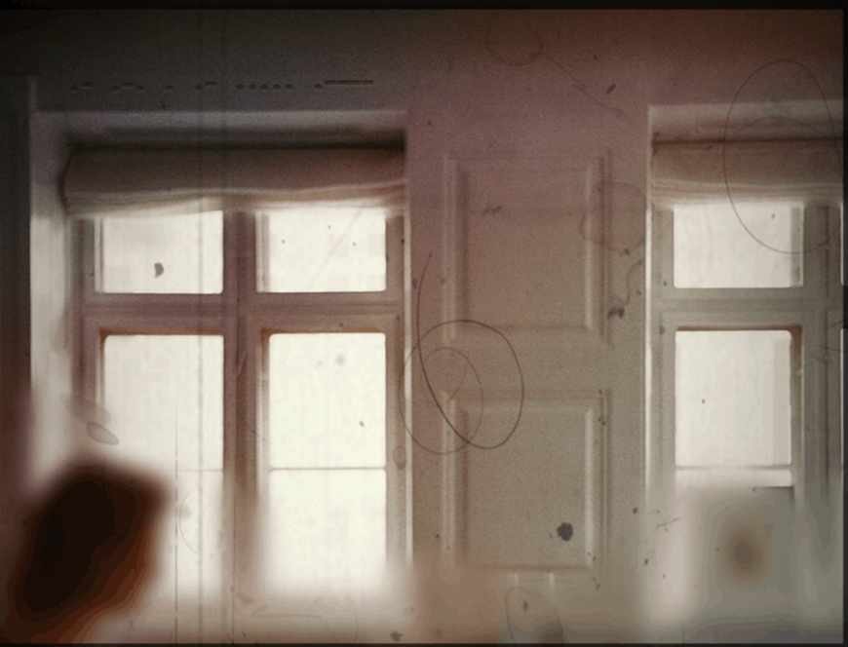

*This is a random question I found on the internet, the images will be different and the level of question will be better.*

**Webpage planning:**

There are 4 main types of pages:

1. The registration page: This page will take the name, registration number and other required details
2. The level page: each level page will have an image inside a frame and the written content under it with the code or riddle. A space will be provided of answer
3. Cut-scene page: an image and Content will be placed inside a image of scroll
4. The result page: displays the result of the game and points scored.

**Requirement:**

1. Content for each level and cut scene
2. Riddles or codes for each level
3. Images related to the level and cut scene
4. Final riddle which is related to all the answers of the previous levels
5. A web page to integrate all the above requirement
6. A database for storing participant info and results

**Timeline :**

|  |  |
| --- | --- |
| **Event** | **Expected dates** |
| The preparation of website starts | 20th June 2020 |
| Preparation of website completed | 28th June 2020 |
| Publicity of the event | Till 30th June 2020 |
| Commencement of event | 1st July 2020 |
| End of event | 3rd July 2020 |